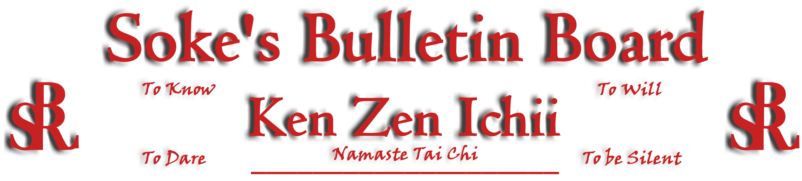
www.kenzenichii.com

February 2011
Promotions
House of Soke II
Congratulations to Sensei Chris Kelly on his promotion to 4th Degree Black Belt (Yodan)
Congratulations to Jordan DeSilva on earning the rank of Green Belt

Crush Fitness
Congratulations to Eduardo Geraldo on earning the rank of Yellow Belt

House of Soke
Ous! I will conduct the Next Level Seminar on March 5, 2011 from 2:00 to 4:00 pm. It will commemorate my 40 year anniversary Black Belt test under Master Orlando Centeno. The House of Soke II will host this event. Special guests are expected and the entire BSR/KZI is invited to come and enjoy…Soke Dwight Childress

House of Soke II
Welcome new students Marla Lee, Sambou Kamissoko, Carlos Hunter, Dewayne Fields and Bob Grail.

It was good to hear from Barath “Flash” Vasudevan and prosperous wishes are extended to him and his family in Seattle, Washington.
BSR Modern Martial Arts School
All is going well.

Sapphire Dragons
All is well with the Sapphire Dragons.

Ken Zen Ichii Japan
All is going well.
KZI - Tennessee
The self-defense seminar at FWO was a great success. Special thanks to Bobby Linsay for organizing the event. We look forward to making this a recurring event.

Sensei Calabrase has created a repository of/for photo's and other media available to all BSR black-belts. If anyone would like access please contact him at mcalabrase.com for access information. We also ask that all members please either upload their KZI/BSR photos or send them Sensei Calabrase to be included in the repository. Our specific goal is to get pictures from EVERY BLACK-BELT TEST possible but all KZI/BSR relevant photos are being sought. Thank you for your assistance.

Crush Fitness
Welcome new student Mia DeRubeis.

The Golden Gloves Boxing Championships were held on February 5th at Mid Hudson Civic Center.

Hudson Valley RyuTe Kan
All is going well.

KZI NEWSLETTER – February 2011
Page 2 of 2
Pearl’s of Wisdom

The Thin Line Between Ego and Confidence By Nicholas Yong

(I came across this article and find it clearly explains the difference between ego and confidence-Shihan Baker)
It’s hard not to notice that many great people have huge egos. You probably need that super-inflated sense of self-belief to get you to high places. But take care that you do not get over-inflated with hot air.
Having an “ego” is an integral part of character and personality. It is no coincidence that successful individuals from Donald Trump to Muhammad Ali are often imbued with an unshakable sense of importance.
They certainly did not succeed by being content with the status quo. They possess that electrifying X-factor that makes them believe that they are better — special even — than everyone else.
“Everyone loves a winner,” so the saying goes, and it’s certainly true that people with strong personalities often attract a huge following. But it’s also often the case that people with huge egos are a massive turn-off. So why do we have these mixed reactions?
Perhaps it’s best to start with a clear definition of what we mean by having an “ego”. We usually think of people with an inflated opinion of themselves, justified or otherwise. There is generally a negative connotation attached to that word. But having an ego should not be confused with having self-respect.
The person with self-respect or confidence simply likes himself for what he is and has a realistic appreciation of his own abilities. This self-respect/confidence is not contingent on success because there are always failures to contend with. Neither is it a result of comparing ourselves with others because there is always someone better. Simply put, it’s about being confident in your abilities without being conceited at the same time.
This form of confidence is highly infectious. It is an enduringly attractive and inspiring quality that breeds equal amounts of energy and passion in others. Even when a team is dying on its feet, it only takes one confident, charismatic leader to make all the difference.
Too much ego is bad
We are all familiar with the colleague/boss/acquaintance who runs other people down, speaks to one and all with a lack of respect, and generally behaves like God’s gift to man. They have no lack of confidence in themselves, it seems. In fact, you could justifiably say that they have too much of it. When self-confidence crosses the line to become arrogance and conceit, it creates the egoistical people whom we all love to hate.
No matter the depth of your abilities, arrogance breeds disrespect, and ultimately enemies who will be more than tempted to do you in. Even if you know that you are brighter and better looking than others, there is no need to announce it to the whole world.
You should be secure enough in your own attributes not to have to constantly make them known to others, or to have to prove your superiority to others. Bragging, showing off and bullying the weak will only expose you for what you really are – an insecure person who cares too much about how other people evaluate you.
Furthermore, blind arrogance leads to mistakes such as underestimating challenges of a task, because you fail to take into account the opinions and abilities of others.
Upon being warned of rebellion in his ranks, Julius Caesar reportedly refused to believe that the men who had marched to war with him would dare turn against him. In the end, he was betrayed by Brutus, his closest ally and friend.
Strike a balance
In the end, neither a lack of humility nor a surfeit of it is desirable. Mythology tells us that Narcissus drowned because he fell in love with his own reflection, and the proud similarly fail to see the cracks in the mirror. On the flip side, the meek will never inherit the earth. Ultimately, the gift of self-belief cannot be a blessing unless it is also tempered with a sense of balance and perspective.

